

Harv.it: Harvest It!

A Community Agro-Produce Trading Platform

Project Documentation

# This Project was developed by

Team Runtime Terror

## Members:

Kanishk Kumar

Shahid Ahamed

Jyotirmaan Srivastava

Second Year Students of

SRM IST, Kattankulathur Campus

During

TEXAS HACKATOGE 23

April 15 2023 – April 16 2023

Problem Statement

Community based Vegetables / Food sharing:

* The web application should allow users to create a profile, and include information such as their location, the type of produce they are growing, and the quantity of excess produce they have available for exchange.
* Users should be able to browse through available produce in their locality and initiate a trade by sending a request to the owner of the produce they are interested in.
* The platform should also incorporate a rating and review system, which enables users to rate and provide feedback on the quality of the produce and the reliability of the trading partner.
* The system should also allow users to track the status of their trades and receive notifications when a trade has been initiated or completed.
* Additionally, the web app could offer a feature that connects users with local farmers markets or grocery stores to sell their produce at a competitive price.

Our Solution:

Harv.IT: A Community based Agricultural Produce Trading Platform. This platform allows the users to have a location-based insight on agro-produce and pricing.

The homepage shows you a Carousel with the Newest Offers. Scrolling down, you can find a list of all the products available through our site.

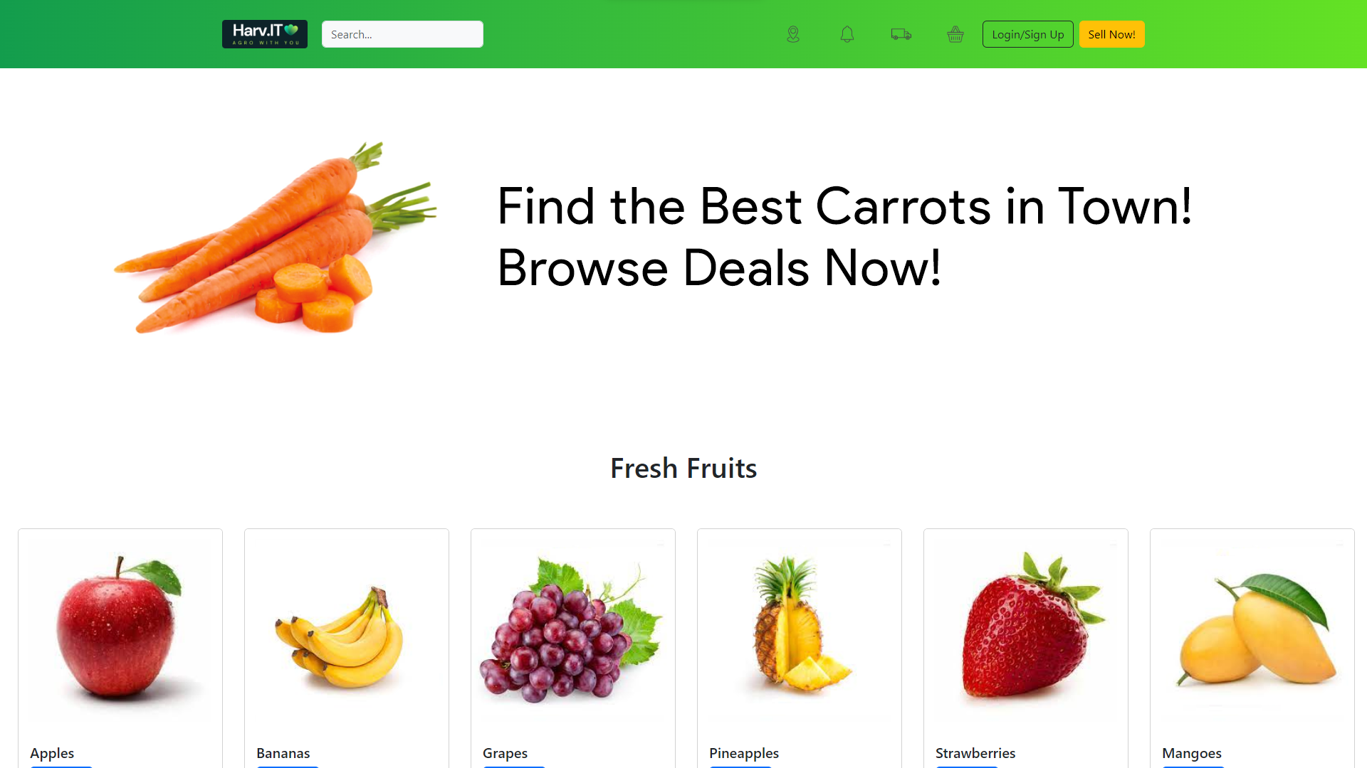

The navigation bar provides the user with a search bar to find the products with either the Seller Name, Location, or Product Name. It also features mini-buttons to set your location, check notifications, track previous orders, view cart. Menu to Login/Signup and Sell items can be found on the top right.



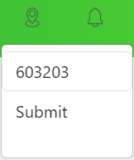The Location menu allows you to enter a pin-code to find nearby buyers and sellers.

The Notification menu shows various account related insights.

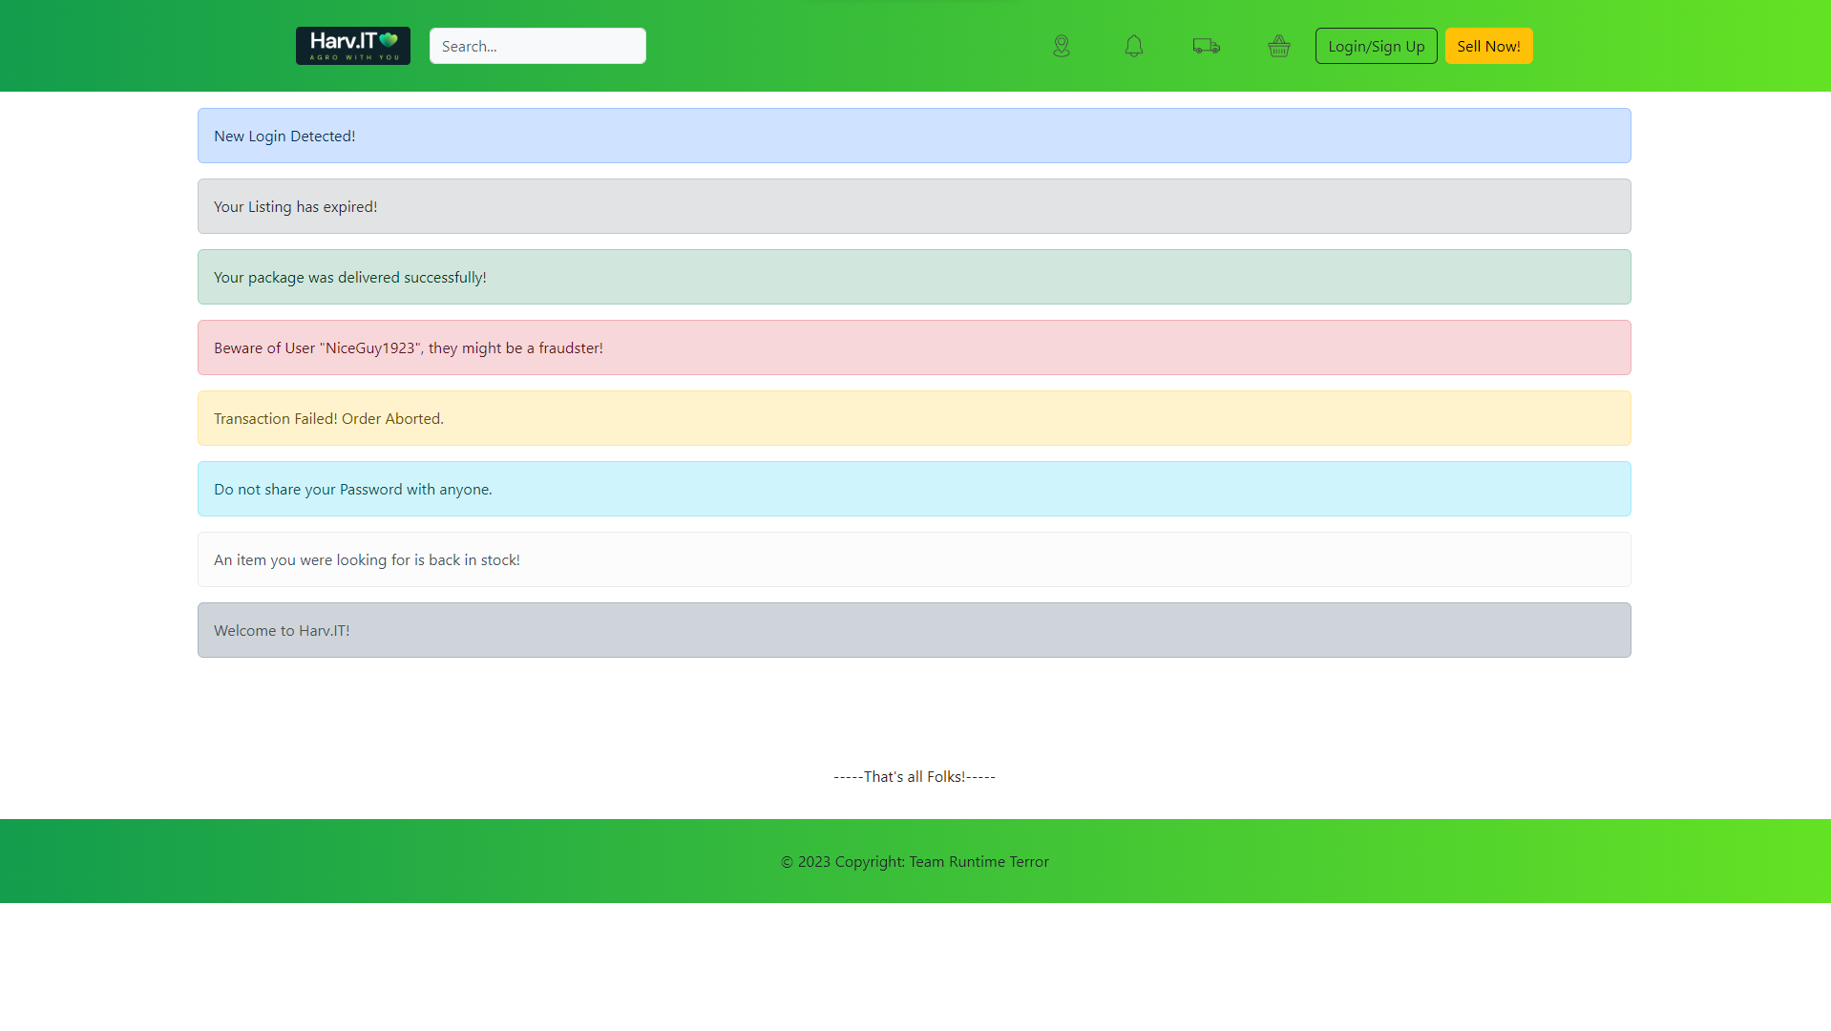

The Track Orders section provides a comprehensive detail of your previous orders’ tracking status.

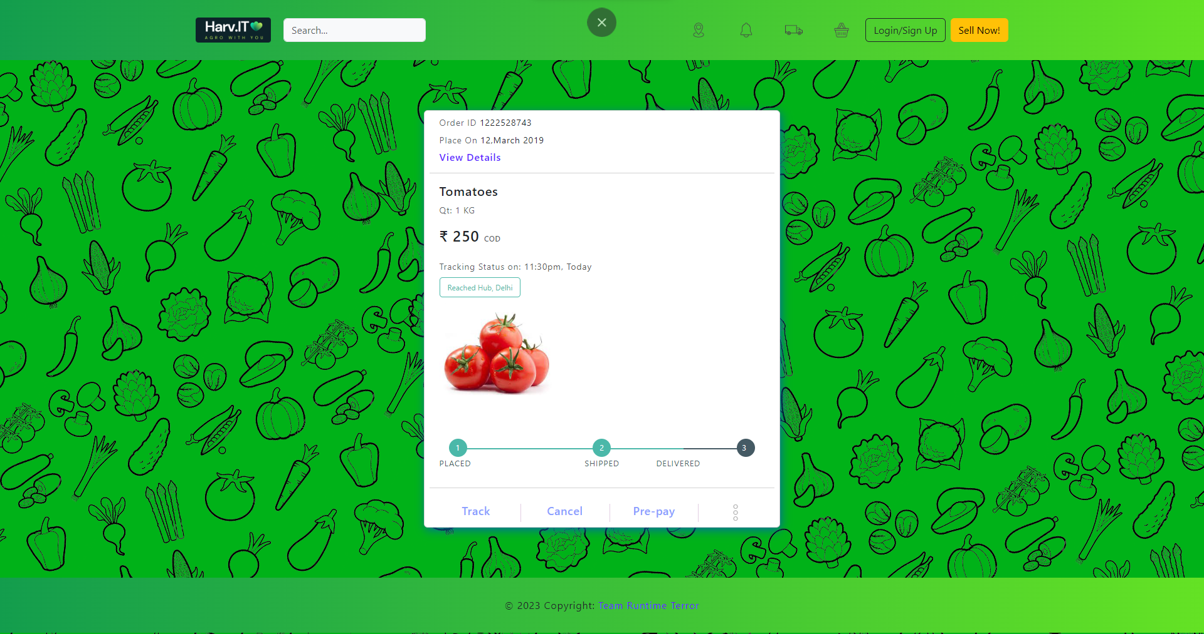

The Cart holds all of your items before you check-out from our store.

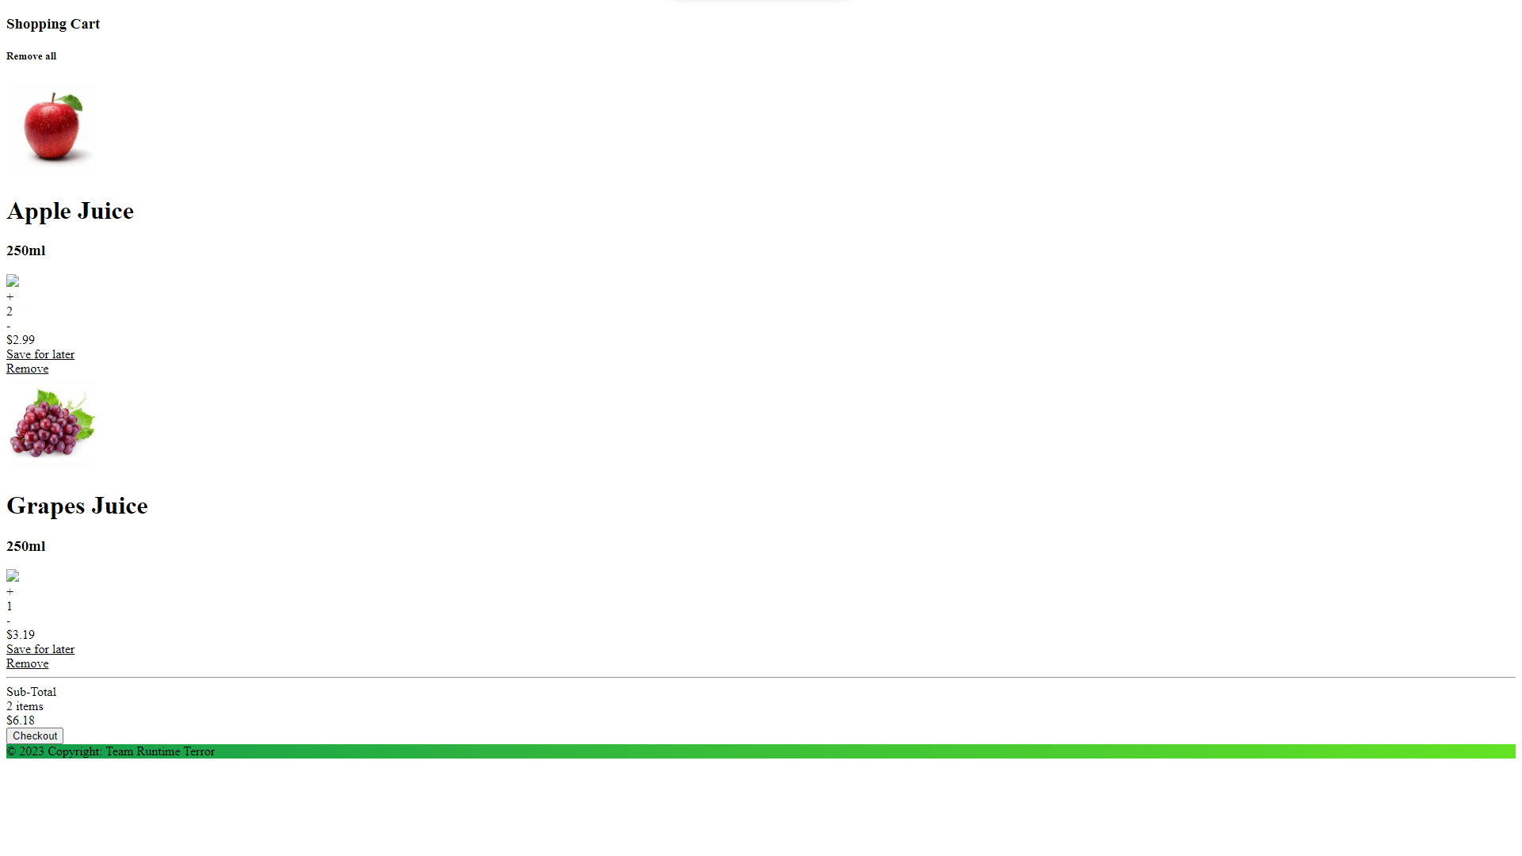

The login page is linked along with the sign up page.

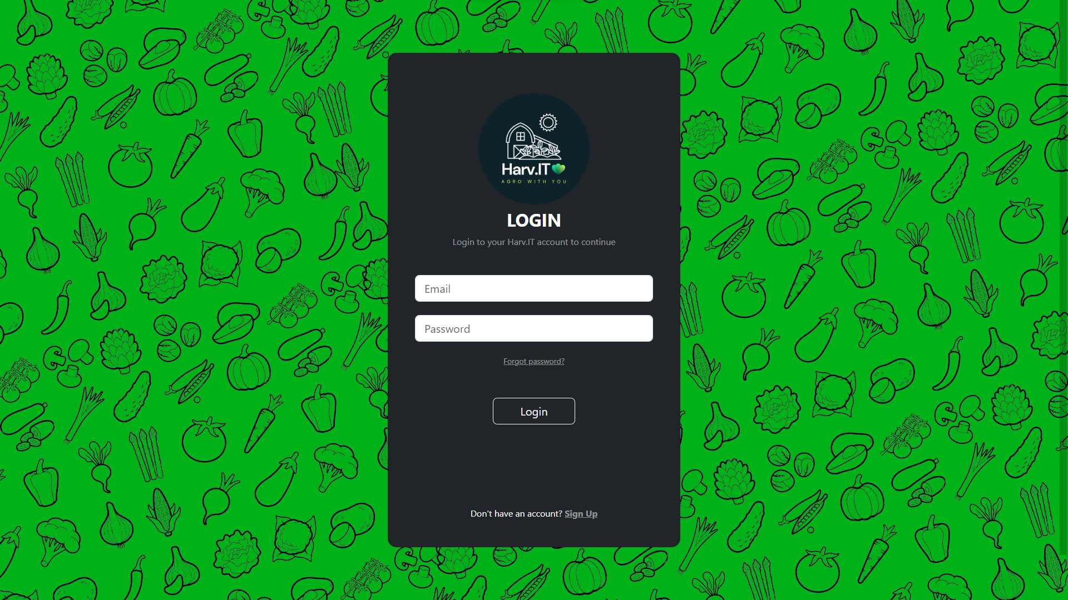

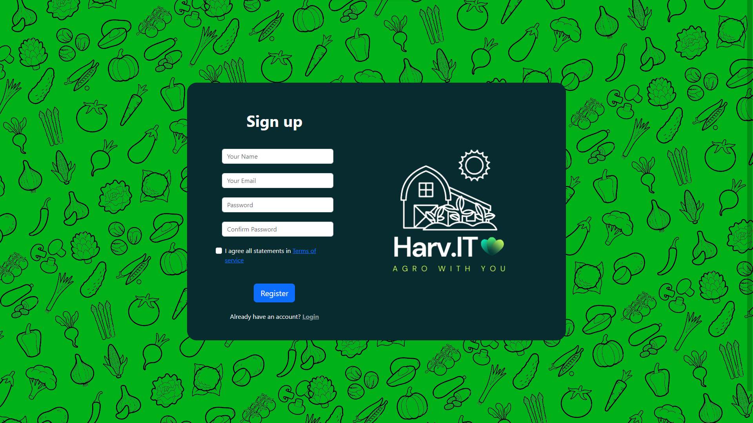

The Sell Now page allows you to create sell listings for your produce.

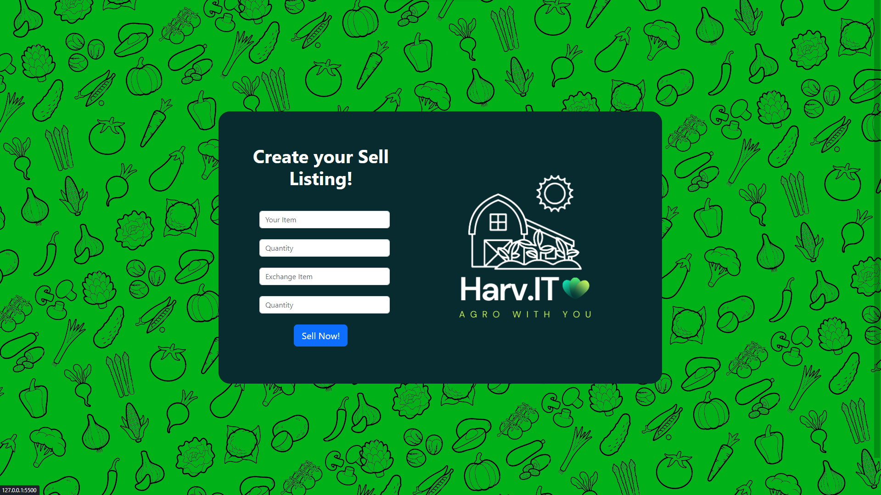

The homepage also allows you to to visit each product’s page with its listings.

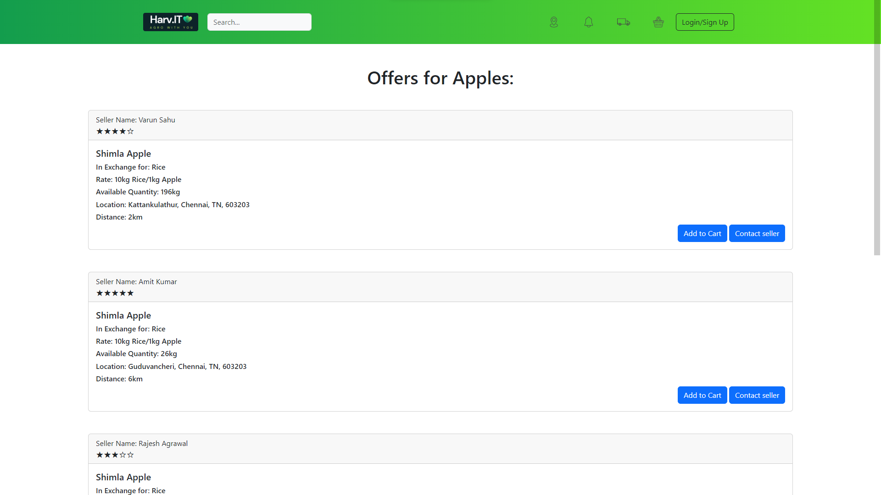

The Contact Seller button opens up an email dialog to contact with the seller.

Each seller is given a rating on a 5-star level.

This project works on HTML/CSS with some level of integration of JavaScript, and MySQL with php.

As for the responsiveness of the Website on mobile, it works pretty well. You may find some screenshots of the same on the next few pages.

